**Buổi học 10/6**

**As a: vai trò**

**Sau love la + ving**

**-fluently: troi chay**

1.

Dear Sir/Madan,

My name is Trang, I am 30 years old. I am from Thanh Hoa. I am not married. From some of my friends, I know that you are looking for manager position and I am interested in this position. I graduated from Hanoi university in 2013, my major in management. I used to do manager position for BienDong Restaurant from 2012 to 2022 .I managed a group of 10 people .I can speak English . I am good at commnutication skills, I am good-looking, hard-working and honest(reliable) . I can work for long hours . I am willing to work at weekend or in the evening. I don’t mind working overtime …. In free time , I love reading books, travelling and playing sports, I think that I can do the job.

If you have any question or need further information , please contact me at 1234 or via [dsadfa@gmail.com](mailto:dsadfa@gmail.com) I am looking forward to hearing from you.

-Education/qualifications

I graduated from Hanoi University in 2026 , my majored in management. I worked as manager for Bien Dong restaurant from 2010 to 2012. I managed 10 people

-work experience

-skill(language, communication)

-strengths: thế mạnh về tính cách, ngoại hình

I am good-looking, hard-working and honest(reliable)

-interests(sở thích)

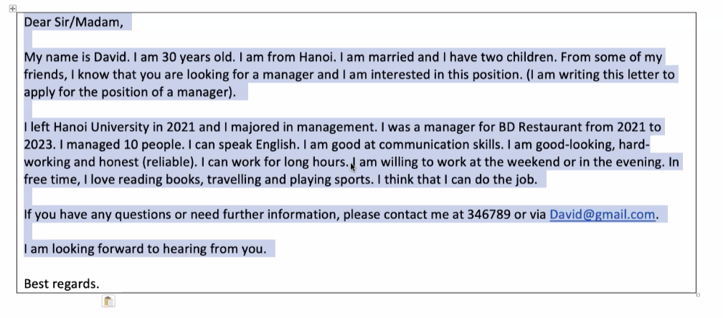

My name is Trang , I am twenty-one. I am from Hanoi. From some my friends , I know your restaurant looking for a manager and I am interested in this position.

I graduated from Hanoi university in 2015 , there I studies major management. I worked as a manager in BienDong restaurant from 2013 to 2031. I managed a group 10 people.I can speak English fluently. I am good communication. I am good-looking,

Hard-work, honest(reliable) . I can work for long hour. I am willing at the weekend or in the evening. I don’t mind overtime(tôi không ngại làm thêm giờ),In free time , I love reading, travelling and playing sports. I believe that I am the best candidate for this position.

2.

-willing : sẵn sàng

-celebrate: kỉ niệm

-occation: dịp

-Oranize an event

Have /hold a birthday party

Had/held

I am happy with your restaurant

I pleased with

I am satisfied(thõa mãn) with

- held a birthday : to chuc sinh nhat

-recommend : gioi thieu

-diverse: da dang

-reasonable : hợp lí

-lovely: tuyệt vời

-tasty: ngon

- fried: chiên

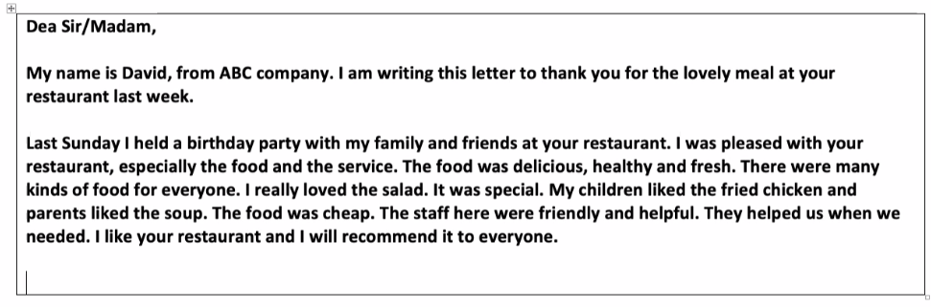

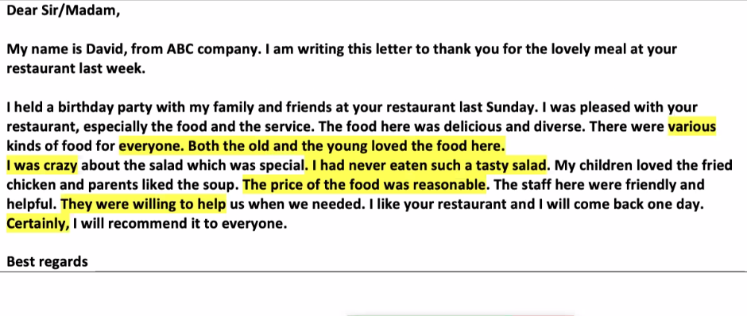

Dear sir

My name is Trang, I am from ACB company. I am wirting this letter to thank you for the lovely meal at your restaurant last week.

I held a birday party with my family and friends at your restaurant last Sunday. I was pleased with restaurant, especially the food and service. The food very delicious and diverse . there are various kind food for everyone. Both the old and young loved the food here

I really crazy for salad dish which was special. I had never eaten tasty salad. My children loved the fried chicken and parents liked the soup. The price of the food was reasonable . The staff here were friendly and helpful. They willing to help us when we needed. I like restaurant and I will come back one day( 1 ngày nào đó).Certainly, I will recommend it to everyone